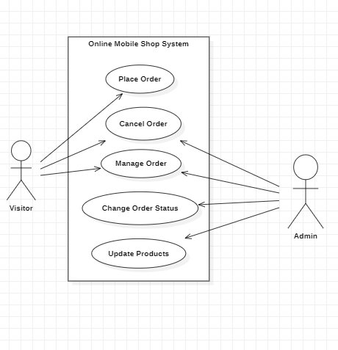

**What is a use case diagram?**

A Use Case Diagram is a type of Unified Modeling Language (UML) diagram that represents the interaction between actors (users or external systems) and a system under consideration to accomplish specific goals. It provides a high-level view of the system’s functionality by illustrating the various ways users can interact with it.

**Elements of a use case digram**

1. **Actors:** Actors are external entities that interact with the system. These can include users, other systems, or hardware devices. In the context of a Use Case Diagram, actors initiate use cases and receive the outcomes. Proper identification and understanding of actors are crucial for accurately modeling system behavior.

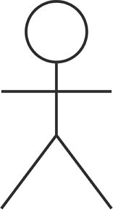

1. .**Use case:** Use cases are like scenes in the play. They represent specific things your system can do. In the online shopping system, examples of use cases could be “Place Order,” “Track Delivery,” or “Update Product Information”.Use cases are represented by ovals.

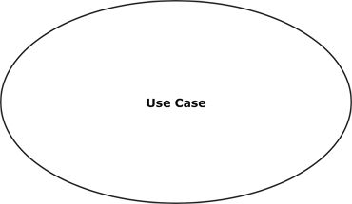

1. **System Boundary:** The system boundary is a visual representation of the scope or limits of the system you are modeling. It defines what is inside the system and what is outside. The boundary helps to establish a clear distinction between the elements that are part of the system and those that are external to it. The system boundary is typically represented by a rectangular box that surrounds all the use cases of the system.

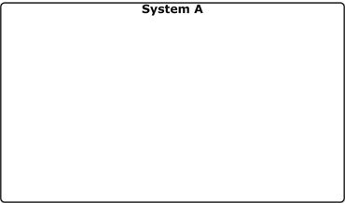

**Use Cases Relationships**

In a Use Case Diagram, relationships play a crucial role in depicting the interactions between actors and use cases. These relationships provide a comprehensive view of the system’s functionality and its various scenarios. Let’s delve into the key types of relationships and explore examples to illustrate their usage.

1. **Association Relationship:** The Association Relationship represents a communication or interaction between an actor and a use case. It is depicted by a line connecting the actor to the use case. This relationship signifies that the actor is involved in the functionality described by the use case.
2. **Include Relationship:** The Include Relationship indicates that a use case includes the functionality of another use case. It is denoted by a dashed arrow pointing from the including use case to the included use case. This relationship promotes modular and reusable design.
3. **Extend Relationship:** The Extend Relationship illustrates that a use case can be extended by another use case under specific conditions. It is represented by a dashed arrow with the keyword “extend.” This relationship is useful for handling optional or exceptional behavior.
4. **Generalization Relationship:** The Generalization Relationship establishes an “is-a” connection between two use cases, indicating that one use case is a specialized version of another. It is represented by an arrow pointing from the specialized use case to the general use case.